**United States Marshals Service**

**FY 2012 Performance Budget**

**President’s Budget**

**Justice Prisoner and Alien Transportation System**

**Revolving Fund**



**February 2011**

This page left intentionally blank

**Table of Contents**

I. Overview of the Justice Prisoner and Alien Transportation System (JPATS) 4

II. Summary of Program Changes 9

**III. Appropriation Language and Analysis of Appropriation Language (N/A)……...……...9**

**IV. Decision Unit Justification**

A. Justice Prisoner and Alien Transportation System 10

Program Description 10

Performance Tables 11

Performance, Resources, and Strategies 14

a. Performance Plan and Report for Outcomes 14

b. Strategies to Accomplish Outcomes 14

**OMB Exhibits:**

**A. Organizational Chart**

**B. Summary of Requirements**

**C. Program Increases/Offsets by Decision Unit (N/A)**

**D. Resources by DOJ Strategic Goal and Strategic Objective**

**E. Justification for Base Adjustments (N/A)**

**F. Crosswalk of 2010 Availability**

**G. Crosswalk of 2011 Availability (N/A)**

**H. Summary of Reimbursable Resources**

**I. Detail of Permanent Positions by Category**

**J. Financial Analysis of Program Increases/Offsets (N/A)**

**K. Summary of Requirements by Grade**

**L. Summary of Requirements by Object Class**

**M. Status of Congressionally Requested Studies, Reports, and Evaluations (N/A)**

**N. 2012 Adjustments to Base by Decision Unit (N/A)**

**O. Schedule of Aircraft**

# I. Overview of the Justice Prisoner and Alien Transportation System (JPATS)

**A.** **Introduction**

JPATS was created on October 1, 1995, by merging the USMS National Prisoner Transportation System and Immigration and Naturalization Service (INS) Air Transport Branch. This merger was based on an August 15, 1994 memorandum in which the Attorney General directed the consolidation [by FY 1996] of the prisoner and detainee air transportation functions that were being performed by the USMS and INS into a single entity to be managed by the USMS. The JPATS mission is to transport federal detainees, deportable aliens and prisoners, including pretrial, sentenced individuals, whether in the custody of the USMS or the Bureau of Prisons (BOP). JPATS also provides prisoner transportation for the Department of Defense (DOD), state, and local law enforcement agencies on a reimbursable, space-available basis. JPATS transports prisoners and detainees in a cost-effective manner without sacrificing the safety of the public, federal employees, or those in custody.

In 1997, Coopers & Lybrand prepared a JPATS 5-Year Strategic Plan that included a recommendation that JPATS be funded through a revolving fund to allow flexibility in its financial planning, operational decision-making, and the delivery of services. On October 1, 1998, JPATS began operating as a revolving fund activity with the goal of having all operating costs reimbursed by customer agencies. The benefits of the JPATS Revolving Fund are: 1) it is a no-year account with a consistent funding stream from the customer agencies, thus not subject to Continuing Resolution restrictions; 2) it operates under the concept of full-cost recovery; 3) it provides for multi-year funding/leasing authority for capital acquisitions; and 4) it has authority to retain proceeds from the disposal of JPATS aircraft and parts. The JPATS Revolving Fund provides stability in costs to the customer agencies since the fund can absorb, on a short-time basis, cost fluctuations for operating expenses such as fuel and major aircraft maintenance. It also simplifies the task of replacing aircraft and obtaining major aircraft parts by enabling managers to extend the cost of equipment purchases or equipment leases over several years, and to plan the procurement of equipment, or equipment lease agreements when needed, rather than waiting for available, appropriated funding.

JPATS receives compulsory guidance from the General Services Administration (GSA), which is charged with monitoring the effective use of all government aircraft in accordance with Office of Management and Budget (OMB) requirements. JPATS follows GSA directives with assistance from Justice Management Division’s (JMD) Facilities and Administrative Services Staff (FASS), a member of GSA’s Interagency Committee for Aviation Policy (ICAP). FASS serves as an effective intermediary between JPATS and GSA, passing along technical and operational advice from GSA-ICAP to JPATS, while transmitting JPATS data to GSA through the Federal Aviation Interactive Reporting System (FAIRS). ICAP provides direct assistance to JPATS through programs like the ICAP Aviation Resources Management (ARMS), which engages professional aviators from other government programs in safety reviews of JPATS operations. The ARMS program offers a comprehensive survey, on request, of an agency's flight program (management/administration, operations, maintenance, safety, and training). GSA puts together a team of aviation experts, which generally spends about two weeks on-site with the requesting agency's aviation program. JPATS completed an ARMS review in December 2007 with no significant findings.

JPATS adheres to all of the Federal Aviation Administration (FAA) public sector aviation rules and regulations regarding aviation safety, operations, and maintenance. JPATS is an organizational component within the USMS with the Assistant Director for JPATS reporting to the Associate Director for Operations of the USMS. USMS was both management and customer for JPATS since its inception in FY 1996 until FY 2006. In FY 2007, USMS Salaries and Expenses funding for prisoner transportation was transferred to the Office of the Federal Detention Trustee (OFDT). OFDT’s control of funds for both detention and transportation is expected to result in greater cost efficiencies. Following congressional intent that OFDT should manage JPATS, the organization is now lead by a Director who reports to the Federal Detention Trustee. The JPATS Revolving Fund budget reflects the anticipated revenue and expenditures that are related to the movement of detainees and prisoners. Program funding requirements are identified in the budget submission of each customer agency.

**B. Issues, Outcomes, and Strategies**

JPATS coordinates with the OFDT, USMS, and BOP to ensure that:

* Detainees and prisoners are transported and detained in a cost effective manner, utilizing procedures that safeguard USMS personnel and the public.
* Persons in custody reach their destinations in a timely manner.

The most prevailing issue facing JPATS in FY 2011 and FY 2012 is the disengagement of the U.S. Immigration and Customs Enforcement (ICE), which will result in a significant reduction to the total JPATS operation. ICE’s departure from JPATS, as set forth in the letter from the Deputy Secretary of the Department of Homeland Security on August 25, 2010, represents a **67 percent** reduction of all JPATS customer business. This reduction represents a loss in operating revenue, and will also require JPATS to close three of five operational facilities and reduce personnel. Due to the abrupt nature of this notification, overhead and general administrative costs cannot fully be divested in an expedient enough manner to minimize the impact on the remaining customers’ billing rates.

JPATS is currently utilizing a long-term leasing strategy that provides increased aircraft reliability, fuel efficiency, and prisoner capacity in the large aircraft leased for all JPATS operations. In FY 2010, the leased aircraft were operating at the following locations: two at Mesa, Arizona; two at Alexandria, Louisiana; and two at Oklahoma City, Oklahoma. With ICE’s departure and the correlating reduction in leased large aircraft flight hours requested, JPATS requirement is reduced to two large aircraft at the Oklahoma City, Oklahoma facility. JPATS did not exercise the 2011 option year on the current long-term aircraft lease. JPATS contracts two large aircraft for Oklahoma City using an existing blanket purchase agreement. The original period of performance is six months with six one-month option periods for greater operational flexibility. JPATS is continuing to analyze and develop new lease options for the Oklahoma City operation. In addition, JPATS has repositioned an owned medium aircraft to Las Vegas, Nevada to further support remaining JPATS customers’ needs. The disengagement of ICE as a JPATS customer also impacted the operation in Aguadilla, Puerto Rico. The operation has reverted back to a single wet leased aircraft, as the mission was originally established, and JPATS is pursuing disposal of the JPATS owned Beechcraft 99 aircraft.

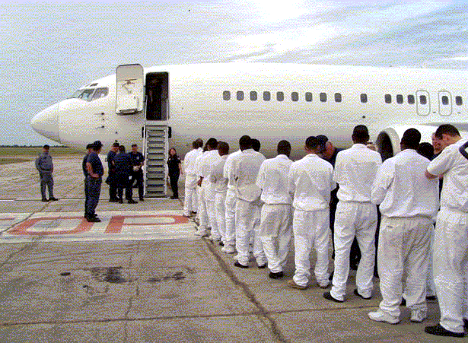

The Oklahoma City hangar has one year remaining on its lease. The annual lease payment is approximately $1 million. OMB Circular A-11 requires agencies to reserve sufficient budgetary authority equal to the net present value of the Government’s total estimated legal obligations over the life of the lease. JPATS obligated $4 million from retained earnings in   
FY 2007 to cover the remaining years of the lease.

The following is a brief summary of the Department’s Strategic Goal and Objective supported by JPATS.

DOJ Strategic Goal III: Ensure the Fair and Efficient Operation of the Federal Justice System

* Protect judges, witnesses, and other participants in federal proceedings, and ensure the appearance of criminal defendants for judicial proceedings or confinement (Goal III, Objective 3.1)

JPATS supports the DOJ Strategic Plan by moving prisoners and detainees as quickly, safely, and as cost effectively as possible. The following chart shows the actual and projected levels of air transportation movements and flight hours for all JPATS customer agencies from FY 2003 to   
FY 2012:

|  |  |  |
| --- | --- | --- |
| Fiscal Year | Air Movements | Flight Hours |
| 2003 | 175,220 | 11,635 |
| 2004 | 176,519 | 11,746 |
| 2005 | 181,951 | 10,512 |
| 2006 | 213,138 | 11,674 |
| 2007 | 244,137 | 14,069 |
| 2008 | 229,392 | 13,171 |
| 2009 | 196,524 | 10,524 |
| 2010 | 206,353 | 10,631 |
| 2011 (Est) | 69,658 | 3,985 |
| 2012 (Est) | 69,658 | 3,985 |

.

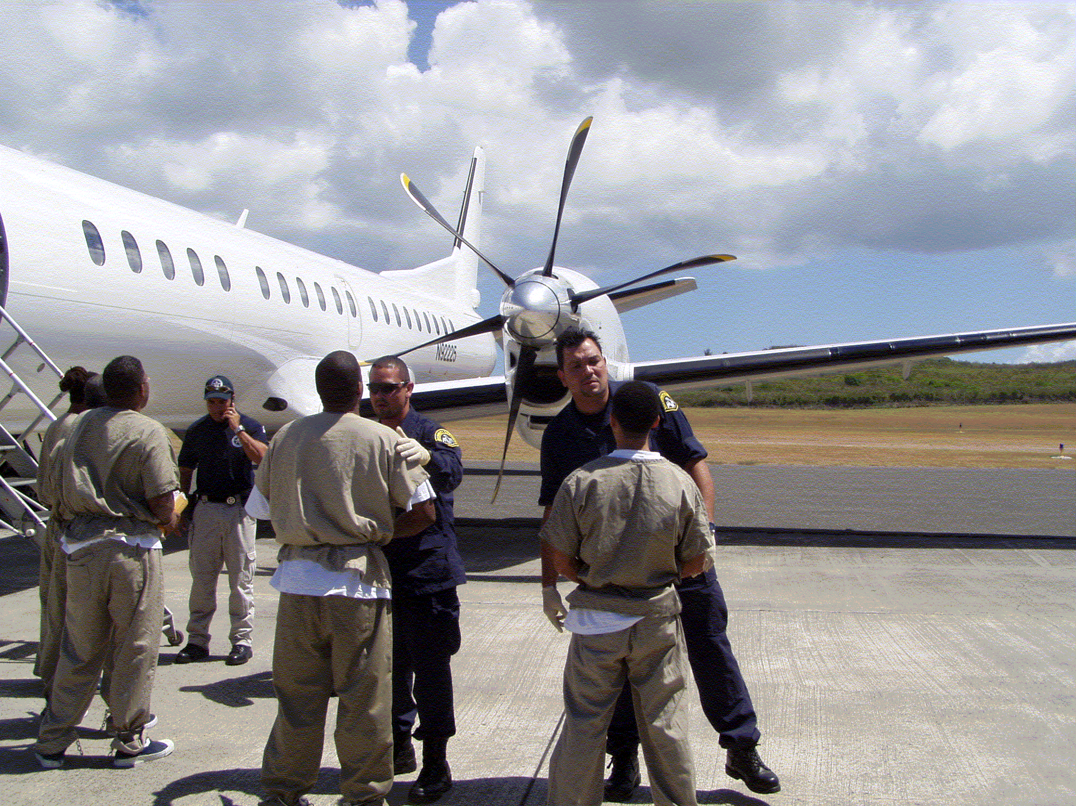

**C. Full Program Costs**

On October 1, 1998, JPATS began operating as a revolving fund activity with total operating costs being reimbursed by customer agencies. A price-per-flying-hour methodology was developed by the JPATS Business Office in conjunction with financial and operational staff members from the Justice Management Division (JMD), BOP, ICE, and the USMS. This methodology was implemented in 2002, and replaced the price-per-movement methodology that was used during the first 3 years of JPATS operation. The goal was to develop an accurate, fair, and equitable pricing methodology for all agencies with full cost recovery. This was accomplished by following OMB Circular A-126 guidelines that identify fixed and variable cost categories and by establishing specific prices-per-flying-hour for JPATS customers. Using this methodology, fixed and variable costs were identified by aircraft frame size (large, medium, or small). JPATS budget projections have incorporated an additional tool known as “activity based costing” to further refine the accuracy of customer pricing initiatives begun in FY 2002. In FY 2006, the methodology was further refined to a price-per-flight-hour-per-seat basis. Customers are billed based on the number of flight hours and the number of seats they actually utilize to move their prisoners/detainees. Aircraft usage requirement projections are provided by the customer agencies prior to the beginning of the budget cycle.

**D. Performance Challenges**

JPATS faces a variety of challenges in accomplishing its mission. These challenges fall into two broad categories:

**External Challenges**

The JPATS aviation program is subject to a variety of influences and regulations external to the Department of Justice. JPATS workload is generated by the projected needs of other federal agencies, particularly the federal judiciary. JPATS determines the schedule to move prisoners based on the appearance dates specified in court orders.

JPATS must continually anticipate the future needs of the customer. FY 2011 customer requirements were reduced significantly due to ICE’s departure from the JPATS program. The loss of this customer results in the ultimate closure of three of five JPATS operational facilities. JPATS closed the facility in Aguadilla, Puerto Rico and co-located with the USMS district office in San Juan. During FY 2011, JPATS ceased to operate the Mesa, Arizona and Alexandria, Louisiana facilities. In addition, in FY 2011 JPATS began operations in Las Vegas, Nevada in support of the Nevada Southern Detention Center in Pahrump, Nevada. The operation will utilize one JPATS owned, medium aircraft. JPATS utilized budget methodology in accordance with OMB Circular A-126 guidelines as well as activity based costing.

**Internal Challenges**

The greatest internal challenge is ensuring the safety of the aircraft, staff, and prisoners/detainees. A Safety Officer and a formal safety program are in place to meet this challenge. The Safety Officer provides constant monitoring of the aviation program and conducts numerous training sessions each year to help JPATS continue to meet its high standards of aviation safety.

A second significant internal challenge is ensuring that JPATS has access to an adequate number of aircraft to meet customer demands. When a leased aircraft requires maintenance, the aircraft leasing company must locate a replacement aircraft for the scheduled mission. If a replacement aircraft cannot be immediately located, or if a JPATS-owned aircraft requires unscheduled maintenance, JPATS either locates another leased aircraft or reschedules the mission. The acquisition strategy of leasing newer, more reliable aircraft will increase the operational readiness of the air fleet, reducing unscheduled downtime and enabling JPATS to meet customer missions.

A third internal challenge is appropriately staffing each scheduled flight with flight personnel/security officers to secure the prisoners/detainees being transported, to include a Public Health Service (PHS) nurse or contracted medical support to attend to any urgent health issues.

JPATS currently provides ground security at all airlift stops for the loading and transferring of prisoners/detainees. Through a standardized training program and the use of standardized weapons, these specialized security personnel strengthen the safety of prisoner movements. Meeting these challenges will ensure that the JPATS missions will fly as scheduled in the safest manner possible.

# II. Summary of Program Changes

|  |  |  |  |  |  |
| --- | --- | --- | --- | --- | --- |
| **Item Name** | **Description** | | | | **Pages** |
|  | **Pos.** | **FTE** | **Dollars ($000)** |
| Customer Requirements | ICE disengagement | (73) | (73) | ($77,677) | 5,8 |
| Total |  | (73) | (73) | ($77,677) |  |

.

III. **Appropriation Language and Analysis of Appropriations Language (N/A)**

Not applicable because the JPATS Revolving Fund is not an appropriated account.

**I**V**. Decision Unit Justification**

## A. Justice Prisoner and Alien Transportation System

|  |  |  |  |
| --- | --- | --- | --- |
| Justice Prisoner and Alien Transportation System – TOTAL | Perm. Pos. | FTE | Amount ($000) |
| 2010 Operating Level | 196 | 196 | $135,252 |
| 2011 Adjustments to Base and Technical Adjustments | 0 | 0 | 0 |
| 2011 Changes to Operating Level | (73) | (73) | ($77,677) |
| 2011 Operating Level | 123 | 123 | $57,575 |
| 2012 Changes to Operating Level | 0 | 0 | 0 |
| 2012 Operating Level | 123 | 123 | $57,575 |
| Total Change 2010-2011 | (73) | (73) | ($77,677) |

*Note-Depreciation is not included

### 1. Program Description

JPATS currently moves federal prisoners and detainees by air, including sentenced, pretrial and deportable aliens, whether in the custody of the U.S. Marshals Service (USMS), or Bureau of Prisons (BOP). JPATS also transports Department of Defense and state and local prisoners on a reimbursable, space-available basis. The JPATS goal is to move prisoners and deportable aliens safely and securely, in the most cost efficient manner possible.

Customer agencies provide projected aircraft utilization requirements. JPATS estimates non-federal requirements based on historical data. Due to the disengagement of ICE in FY 2011 and FY 2012, and the corresponding reduction in customer requirements, JPATS was be forced to close three operational locations. The corresponding decreases to JPATS FTE are yet to be finalized, but are estimated to be a decrease of 73 positions and 73 FTE. The FY 2012 budget reflects program adjustments to support a decrease to customer requirements.

JPATS is committed to ensuring that each scheduled flight is staffed with qualified flight personnel to safely operate each aircraft, that adequate security officers are present to ensure the safety of the detainees/prisoners being transported, and that at least one medical professional is present for any medical emergency. In response to current and projected external influences JPATS operational support FTE will be significantly reduced, however, JPATS will continue to safely and efficiently satisfy service demands. The chart below shows the projected personnel requirements by location in FY 2012:

|  |  |  |  |  |  |  |  |
| --- | --- | --- | --- | --- | --- | --- | --- |
| **Proposed Personnel Requirements by Location** | | | | | | | |
|  | Alexandria, LA | Kansas City, MO | Oklahoma City, OK | Phoenix, AZ | Puerto Rico | Las Vegas, NV | Total |
| JPATS Total | 0 | 57 | 58 | 0 | 1 | 7 | 123 |

### 2. Performance Tables

|  |  |  |  |  |  |  |  |  |  |  |  |  |  |
| --- | --- | --- | --- | --- | --- | --- | --- | --- | --- | --- | --- | --- | --- |
| **PERFORMANCE AND RESOURCES TABLE** | | | | | | | | | | | | | |
| **Decision Unit: Justice Prisoner and Alien Transportation System** | | | | | | | | | | | | | |
| **DOJ Strategic Goal/Objective: III: Ensure the Fair and Efficient Operation of the Federal Justice System. 3.1 Protect judges, witnesses, and other participants in federal proceedings, and ensure the appearance of criminal defendants for judicial proceedings or confinement.** | | | | | | | | | | | | | |
| **WORKLOAD/ RESOURCES** | | **Target** | | **Actual** | | **Projected** | | **Projected** | | **New FY2011 Target** | | **Requested (Total)** | |
|  | | **FY 2010** | | **FY 2010** | | **FY 2011 President’s Budget** | | **FY2011**  **Projected Changes** | | **FY 2011 Program** | | **FY 2012 Request** | |
| 1. Number of requests for transportation of prisoners | | 223,768 | | 216,420 | | 247,864 | | (145,437) | | 102,427 | | 102,427 | |
| **Total Costs and FTE (reimbursable FTE are included, but reimbursable costs are bracketed and not included in the total** | | **FTE** | **$000** | **FTE** | **$000** | **FTE** | **$000** | **FTE** | **$000** | **FTE** | **$000** | **FTE** | **$000** |
| **196** | **$135,252** | **196** | **$115,639** | **196** | **$142,194** | **(73)** | **($84,619)** | **123** | **$57,575** | **123** | **$57,575** |
| **TYPE/ STRATEGIC OBJECTIVE** | **PERFORMANCE** | **FY 2010 Requirements** | | **FY 2010 Actual (est.)** | | **FY 2011 Requirements** | | **FY 2011**  **Projected Changes** | | **FY 2011 Program** | | **FY 2012 Request** | |
| **Program Activity** |  | **FTE** | **$000** | **FTE** | **$0** | **FTE** | **$000** | **FTE** | **$000** | **FTE** | **$000** | **FTE** | **$000** |
| **1. Prisoner Movement** | **196** | **$135,252** | **196** | **$115,639** | **196** | **$142,194** | **(73)** | **($84,619)** | **123** | **$57,575** | **123** | **$57,575** |
| Performance Measure | 1. Number of prisoner and detainee air movements accomplished. | 213,335 | | 206,353 | | 214,709 | | (145,051) | | 69,658 | | 69,658 | |
| Performance Measure | 2. Number of hours to accomplish air movements. | 10,100 | | 10,631 | | 10,825 | | (6,840) | | 3,985 | | 3,985 | |
| Efficiency Measure | 3. Average cost per hour for large aircraft. | $9,800 | | $10,908 | | $12,200 | | $2,972 | | $15,172 | | $15,172 | |
| Efficiency Measure | 4. Average cost per hour for small aircraft. | $5,600 | | $7,499 | | $6,400 | | $90 | | $6,490 | | $6,490 | |
| Efficiency Measure | 5. Average age of JPATS owned (in use) aircraft (years). | 25 | | 25 | | 26 | | (6) | | 20 | | 21 | |
| Performance Measure | 6. Percent of time JPATS owned aircraft not available to fly due to unscheduled maintenance | 3.8% | | 8.0% | | 3.8% | | 0 | | 3.8% | | 3.8% | |
| Performance Measure | 7. Number of: |  | |  | |  | |  | |  | |  | |
| a. Incidents on JPATS movements | 0 | | 0 | | 0 | | 0 | | 0 | | 0 | |
| b. Injuries on JPATS aircraft |  | |  | |  | |  | |  | |  | |
| i. Prisoner injuries | 0 | | 0 | | 0 | | 0 | | 0 | | 0 | |
| ii. JPATS personnel injuries | 0 | | 0 | | 0 | | 0 | | 0 | | 0 | |
| **Outcome Measures** | 8. Number of: |  | |  | |  | |  | |  | |  | |
| a. Accidents involving JPATS aircraft | 0 | | 0 | | 0 | | 0 | | 0 | | 0 | |
| b. Escapes from JPATS aircraft | 0 | | 0 | | 0 | | 0 | | 0 | | 0 | |

*\* Due to the disengagement of ICE all numbers are subject to change. Projected FY2011 changes are included. No changes to program FY 2011 to 2012, except additional one year’s aging of aircraft.*

**A. Definition of Terms or explanations for Indicators.**

Workload:

1. JPATS receives requests to move prisoners and determines the appropriate mode of transportation (i.e., ground and/or air movement). JPATS uses the JPATS Transportation module within the JPATS Management Information System (JMIS), to schedule and track movements electronically.

Performance Measures:

1. The number of air movements accomplished using JPATS owned or leased aircraft.

2. Represents the number of flight hours accomplished. Customer agencies provide estimated flight hours for budget development.

3. Represents the average cost-per-hour for large (75-140 passengers) aircraft. Individual prices for cost-per-hour were developed for each customer. Prior to setting outyear targets, JPATS requests customer projection of services required (how many flight hours needed). Further, the analysis performed to project future costs includes the inflationary factors for employee pay raises and the escalating costs for non-labor categories such as aircraft leases, space rental, the market price for fuel, and other supplies. Additional adjustments were made for site closure and personnel losses

4. Represents the average cost-per-hour for small (8-50 passengers) aircraft. Individual prices for cost-per-hour were developed for each location utilizing activity based costing methodology. Prior to setting outyear targets, JPATS requests customer projection of services required (how many flight hours needed). Further, the analysis performed to project future costs includes the escalating costs mentioned above in #3.

5. Depicts the average age of owned aircraft in the JPATS fleet. Aircraft that are beyond economical repair and sold are excluded from the fleet’s average age. As the aircraft age, the cost to maintain increases and availability decreases due to increased maintenance required.

6. Unscheduled maintenance causes decreased ability to meet mission goals along with increased operating costs.

7 and 8. Incident reports are filled out and tracked whenever a critical event occurs, such as a prisoner escape or flight accident.

**B**  **Factors Affecting FY 2011 and FY 2012 Plans.**

Significant reductions in customer requirements will cause the eventual closure of three JPATS operational facilities. JPATS will close the facility in Aguadilla, Puerto Rico and co-locate with the USMS district office in San Juan. Facilities in Mesa, Arizona and Alexandria, Louisiana will cease operations in FY 2011. All variable and operational costs have been removed leaving minimal fixed costs required to maintain the facilities, to be divested in the eventual closure of these two locations. The budget for these two facilities includes all known labor costs and assumes full on board manpower strength. Due to the uncertainty of the date, JPATS cannot totally divest itself of these costs. This may lead to the necessity of modifications to the numbers and amounts presented in the budget transmission. In addition, in FY 2011 JPATS has begun operations in Las Vegas, Nevada in support of the Nevada Southern Detention Center in Pahrump, Nevada. The operations will utilize one JPATS owned, medium aircraft. Current budget methodology, to include all OMB Circular A-126 guidelines and activity based costing, was utilized to calculate the program cost for the new operational facility.

|  |  |  |  |  |  |  |  |  |  |  |  |  |  |
| --- | --- | --- | --- | --- | --- | --- | --- | --- | --- | --- | --- | --- | --- |
| **PERFORMANCE MEASURE TABLE**  **Decision Unit: Justice Prisoner and Alien Transportation System** | | | | | | | | | | | | | |
| **Decision Unit: Justice Prisoner and Alien Transportation System** | | **FY 2002** | **FY 2003** | **FY 2004** | **FY 2005** | **FY 2006** | **FY 2007** | **FY 2008** | **FY 2009** | **FY 2010** | **FY 2011** | **FY 2012** | |
| **Actual** | **Actual** | **Actual** | **Actual** | **Actual** | **Actual** | **Actual** | **Actual** | **Actual** | **Target** | **Target** | |
| **Performance Measure** | Number of prisoner and detainee air movements accomplished. | 162,695 | 175,220 | 176,519 | 181,951 | 213,138 | 244,137 | 229,392 | 196,524 | 206,353 | 69,658 | | 69,658 | |
| **Performance Measure** | Number of hours to accomplish air movements. | 11,363 | 11,635 | 11,746 | 10,512 | 11,674 | 14,069 | 13,171 | 10,524 | 10,631 | 3,985 | | 3,985 | |
| **Efficiency Measure** | Average cost per hour for large aircraft. | $8,385 | $7,522 | $7,999 | $8,542 | $8,642 | $8,406 | $10,568 | $10,335 | $10,908 | $15,172 | | $15,172 | |
| **Efficiency Measure** | Average cost per hour for small aircraft. | $3,712 | $3,181 | $4,062 | $3,939 | $5,327 | $4,680 | $5,694 | $5,204 | $7,499 | $6,490 | | $6,490 | |
| **Efficiency Measure** | Average age of JPATS owned (in use) aircraft (years). | 25 | 14 | 22 | 24 | 21 | 21 | 22 | 22 | 25 | 20 | | 21 | |
| **Performance Measure** | Percent of time JPATS owned aircraft not available to fly due to unscheduled maintenance | 10.0% | 4.0% | 4.0% | 4.0% | 4.0% | 4.0% | 2.5% | 2.6% | 8.0% | 3.8% | | 3.8% | |
| **Performance Measure** | Incidents on JPATS movements | 0 | 0 | 1 | 2 | 0 | 1 | 0 | 1 | 0 | 0 | | 0 | |
| **Performance Measure** | Prisoner injuries on JPATS aircraft | 0 | 0 | 0 | 0 | 0 | 0 | 0 | 0 | 0 | 0 | | 0 | |
| **Performance Measure** | JPATS personnel injuries on JPATS aircraft | 6 | 3 | 0 | 2 | 0 | 0 | 0 | 0 | 0 | 0 | | 0 | |
| **Outcome Measure** | Accidents involving JPATS aircraft | 0 | 0 | 0 | 1 | 0 | 0 | 0 | 0 | 0 | 0 | | 0 | |
| **Outcome Measure** | Escapes From JPATS aircraft | 0 | 0 | 0 | 0 | 0 | 0 | 0 | 0 | 0 | 0 | | 0 | |

*\* Due to the disengagement of ICE all numbers in FY2011 and FY2012 are subject to change.*

### 3. Performance, Resources, and Strategies

#### a. Performance Plan and Report for Outcomes

JPATS currently provides ground security at all airlift stops for the loading and transferring of prisoners/detainees, historically provided by USMS, BOP, and ICE personnel. Through a standardized training program and the use of standardized weapons, these specialized security personnel strengthen the safety of prisoner movements. The designated Safety Officer provides constant monitoring of the aviation program and conducts numerous training sessions each year to help JPATS continue to meet its high standards of aviation safety. Also, the acquisition strategy of leasing newer, more reliable aircraft has increased the operational readiness of the air fleet, reducing unscheduled downtime and enabling JPATS to meet customer missions.

#### b. Strategies to Accomplish Outcomes

FY 2012 customer program level requirements resulted in changes to both prisoner and detainee air movements and flight hours. To more accurately reflect current trends, FY 2012 targets for the following measured items have been adjusted:

* Number of prisoner and detainee air movements accomplished;
* Number of hours to accomplish air movements;
* Average cost per hour for large aircraft, and;
* Average cost per hour for small aircraft, and
* Average age of JPATS owned (in use) aircraft (years).