SAMPLE CHAPTER 7 CASES AND ILLUSTRATIVE FORMS 1, 2, AND 3

SAMPLE CHAPTER 7 CASE #1 AND ILLUSTRATIVE FORMS 1, 2 AND 3

Sam Martin, dba Martin Cards (“Debtor”), filed bankruptcy on November 20, 2002, in a non-community property state and Jenny Ward (“Ward”) was appointed the chapter 7 trustee. Ward’s interim report is filed annually as of June 30, 2003. Ward submitted the attached Forms 1 and 2 showing the activity in the case from November 20, 2002, through June 30, 2003.

Ward obtained the following information regarding Debtor’s assets from an analysis of: (1) the petition, schedules and statement of financial affairs filed by Debtor; (2) Debtor’s testimony at the § 341(a) meeting held on December 20, 2002, and (3) the information received from creditors and other parties-in-interest. Debtor has not amended the schedules and statements originally filed on November 20, 2002.

Checking Account (Asset #1) - Debtor listed a checking account balance of $500 in Schedule B. Cash is not exempt in the state in which Debtor filed bankruptcy. Ward recovers the $500 on December 10, 2002. Ward then promptly obtains a federal tax identification number, opens an estate money market account, and deposits the $500 into the account. Ward records this initial deposit on Form 2 using Uniform Transaction Code (UTC) 1129-000, Liquidation of Other Schedule B Property.

123 Ocean View – Rental Property (Asset #2) and Ocean View Rent Receivable (Asset #8) - Debtor listed a rental house located at 123 Ocean View in Schedule A valued at $100,000 encumbered by a valid and perfected lien securing a debt of $30,000. At the time the petition was filed on November 20, 2002, the Debtor had not yet received the November rent in the amount of $500 from the tenant, Steve James. The Debtor listed $500 as rent receivable in Schedule B.

Ward determines the value of the rental property to be $63,000 ($100,000 scheduled value minus $30,000 lien minus $7,000 (7%) for estimated costs of sale, including realtor’s commission, taxes and closing costs). Ward records this amount in Form 1, Column 3.

Ward collects the November rent on December 15, 2002, and posts the payment to the Ocean View rent receivable on Form 1, Column 5. She notes “FA” in Column 6 to indicate that the asset has been fully administered. The cash receipt of $500 is also posted on Form 2, with UTC 1122-000, Rents (scheduled).

Because there is equity for the estate in the rental property, Ward decides to continue the lease and collect rent until the property is sold. Ward records post-petition rents as a “scheduled”
asset on Form 1 (Asset #12), lists the petition value as “unknown” in Column 2 and the Estimated Net Value as “N/A” in Column 3, and documents the rents in Column 5, Form 1 and on Form 2 as they are received, using UTC 1122-000, Rents (scheduled). (The correct UTC for post-petition rents, royalties, and dividends depends upon whether the underlying asset is “scheduled” or “unscheduled”.)
On March 1, 2003, Ward obtains court authority to sell the rental property to Joe Fish for $90,000 (UTC 1110-000, Schedule A Real Property), and to pay the following amounts through escrow upon closing of the sale: (a) $30,000 lien encumbering the property (UTC 4110-000, Consensual Real Estate Liens); (b) $5,400 realtor’s fee (UTC 3510-000), (c) $1,200 property taxes (which must be divided between pre- and post-petition on Form 2, UTC 4700-000, Pre-Petition Real Property Tax Liens, and UTC 2820-000, Other Post-Petition State and Local Taxes), and (d) $600 costs of sale (UTC 2500-000, Costs re Sale of Property). No capital gains tax is incurred upon the sale. Form 2 illustrates the correct way to record the gross sale proceeds, deductions and $52,800 in net proceeds from the sale. Ward records the gross sale price of $90,000 on Form 1, Column 5 and notes “FA” in Column 6 to indicate that the asset has been fully administered.

Accounts Receivable (Asset #3), 1999 Chevy Van (Asset #6) & Office Equipment (Asset #7)

National Bank claims a valid and perfected blanket lien against the accounts receivable, 1999 Chevy van, and office equipment as security for its loan of $10,000. As discussed below, Ward estimates that she can collect approximately $9,000 of the accounts receivable, sell the van and the office equipment, payoff the bank’s lien, and realize a $9,700 net benefit for the estate from the administration of these assets.

Analysis of Net Benefit to Estate:
 | Accounts  Receivable | Van | Office  Equipment | Total
Estimated fair market value | $9,000 | $9,000 | $4,000 | $22,000
Estimated costs of sale (10%) | 0 | (900) | (400) | (1,300)
Allocation of payoff to bank¹ | (9,000) | (1,000) | 0 | (10,000)
Estimated tax consequences² | 0 | 0 | 0 | 0
Debtor’s exemption³ | 0 | (1,000) | 0 | (1,000)
Net benefit to the estate | $0 | $6,100 | $3,600 | $9,700

¹ Allocated to the assets in the order they were listed on Schedule B.
² Due to losses from the card business, Ward estimates that no taxes will be due as a result of these transactions.
³ The trustee’s compensation is also a consideration in determining whether or not to administer an asset

Accounts Receivable. Debtor listed accounts receivable of $30,000 in Schedule B generated from his business, Martin Cards. Ward sends demand letters immediately after the § 341(a) meeting. Based on the results of her collection efforts, Ward estimates that only $9,000 of the receivables are collectible. She allocates $9,000 of the National Bank lien to the receivables (as shown above) and records a -0- value to the estate on Form 1, Column 3.

During the reporting period, Ward collects $5,000 from three customers: Hall Cards, Card Enterprises, and Excel Corporation. She records the receipts in the Accounts Receivable Ledger and posts them on Form 1, Column 5 and on Form 2 (UTC 1121-000, Scheduled Notes and Accounts Receivable). On February 28, 2003, Ward disburses the sum of $5,000 to National Bank in partial payment of its lien and documents the disbursement on Form 2 (UTC 4210-000, Consensual Lien-Personal Property and Intangibles). Ward estimates the gross value of the remaining accounts receivable to be $4,000, and discloses this amount on Form 1, Column 6. Ward also discloses as Note 1 on Form 1 that National Bank’s lien encumbers Asset Nos. 3, 6 and 7.

1999 Chevy Van. Debtor listed a 1999 Chevy Van in Schedule B valued at $5,000, and claimed a $1,000 exemption in the vehicle in Schedule C. Ward checks the NADA book and determines that the van is worth $8,000 to $10,000. Ward attributes the remaining National Bank lien to the van (see above) and lists the value of the van on Form 1, Column 3 as $6,100 ($9,000 less $1,000 lien, $1,000 exemption, and $900 estimated costs of sale).

Office Equipment. Debtor also listed miscellaneous office equipment in Schedule B valued at $5,000. Ward determines that the fair market value of the office equipment is only $4,000. Ward lists the petition value of the office equipment as $5,000 in Form 1, Column 2, and discloses the net benefit to the estate of $3,600 ($4,000 fair market value less $400 estimated costs of sale) in Form 1, Column 3.

Sale of 1999 Chevy Van and Office Equipment. On May 2, 2003, Ward obtains court authorization to hire an auctioneer to sell the van and office equipment. On June 15, 2003, the van and office equipment are sold in bulk to Susan Taylor, who also is in the card business, for the sum of $8,000. The auctioneer remits the gross proceeds of $8,000 on June 17, 2003. Ward deposits the funds in the estate money market account and disburses $5,000 for the balance due to National Bank for the lien against the receivables, van and office equipment (UTC 4210-000, Consensual Lien-Personal Property and Intangibles), and $1,200 for auctioneer fees ($1,000 – UTC 3610-000) and expenses ($200 – UTC 3620-000). These transactions are listed on Form 2.

Ward records the gross proceeds from the bulk sale of the van and office equipment on Form 1. Since the auctioneer did not provide a breakdown of the gross proceeds allocable to each asset, Ward uses a reasonable alternative method to allocate the proceeds. Ward prorates the gross proceeds to each asset based on her initial valuation of the asset ($4,000 for the office equipment and $9,000 for the van). Ward posts $5,538 ($8,000 x $9,000/$13,000) for the van (Asset #6) and $2,462 ($8,000 x $4,000/$13,000) for the office equipment (Asset #7) in Form 1, Column 5. Ward posts the deposit of $8,000 on Form 2 and shows under “Description of Transaction” that the proceeds are divided between Assets #6 and #7 (the UTC for both assets is 1129-000, Liquidation of Other Schedule B Property.)

On June 25, 2003, after the National Bank lien has been paid, Ward sends a check to the Debtor for the $1,000 exemption (UTC 8100-002) claimed for the van.

Household Goods (Asset #4) - Debtor listed household goods in Schedule B valued at $2,000, and properly claimed them as exempt in Schedule C. Ward records the value of the household goods to the estate as -0- ($2,000 value less $2,000 exemption) on Form 1, Column 3. Ward also notes on Form 1, Column 6 that the asset is fully administered (FA).

Artwork (Asset #5) - Debtor listed artwork in Schedule B valued at $10,000. Ward obtains court authorization on February 26, 2003, to employ Lily Spence, an appraiser, to perform an appraisal of the artwork for $1,000. Based upon the appraisal, Ward determines that the artwork is worth $15,000. On Form 1, Column 3, Ward records $12,500 as the estimated net value to the estate ($15,000 value less $1,000 appraisal fee, $1,500 costs to sell, and -0- taxes).

Ward pays the court-approved fee of $1,000 to the appraiser on March 31, 2003, and records the payment in Form 2 (UTC 3711-000, Appraiser for Trustee Fees).

Debtor, who is interested in retaining some of the artwork, reaches an agreement with Ward for a private sale of $5,000 worth of the artwork back to the Debtor, payable in five monthly installments of $1,000 each, commencing April 12, 2003. The sale is approved by the court on March 31, 2003 (or properly noticed to creditors by the court and no objections are filed). The remaining artwork is consigned to an art gallery. Ward records the Debtor’s April 12, 2003, payment on Form 1, Column 5, and on Form 2 (UTC 1129-000, Liquidation of Other Schedule B Property). Ward also notes the value of the remaining artwork to be collected/sold on Form 1, Column 6.

On April 20, 2003, Debtor’s check for the first payment is returned to Ward marked “NSF.” Ward redeposits the check and it is paid. Ward records the “NSF” check and the redeposit on Form 2 (using UTC 1129-000 for both transactions). Debtor then fails to make the payments due in May and June. Ward notes on Form 1 as a “major activity affecting case closing” that collection efforts are pending against the Debtor to collect the delinquent payments Ward further notes that a public auction of the remaining artwork is set for August 15, 2003.

One-Half Interest in Homestead (Asset #9) - Debtor listed a residence at 55 Lake Drive in Schedule A which he owned and occupied with his non-debtor spouse (not community property). The total value of the Debtor’s interest plus that of the non-debtor spouse was listed in Schedule A at $75,000. The debtor’s share of the Schedule A value (½ – $37,500) is recorded on Form 1, Column 2. The house is encumbered by a lien of $20,000. Ward determines that the value to the estate is $7,125.
Analysis of Net Benefit to Estate:
½ Interest in
Homestead
Estimated fair market value (100%) | $75,000
Lien (100%) | (20,000)
Real estate commission (5%) | (3,750)
Closing costs | (3,000)
Net | 48,250
½ to debtor’s spouse | (24,125)
Estimated estate capital gain tax | (2,000)
Debtor’s state law homestead exemption | (15,000)
Net benefit to the estate | $7,125

Ward lists the house for sale and obtains an offer of $100,000. Ward then files a motion under
§ 363(h) to sell both the Debtor’s interest and the non-debtor’s interest in the property, and sends notice of the proposed sale to creditors. The Debtor’s spouse objects to the sale, but the objection is overruled and the sale is approved. Ward reflects the gross proceeds realized by the estate as $50,000 in Form 1, Column 5. The net proceeds of $35,500 are recorded on Form 2, Column 5. In Column 4, Ward explains the difference between the gross and net proceeds as follows: $50,000 (½ gross proceeds–UTC 1110-000), less $10,000 (½ lien – UTC 4110-000), less $2,500 (½ real estate fee– UTC 3510-000), less $1,200 (½ property taxes – UTC 4700-000 and UTC 2820-000), and less $800 (½ costs to sell–UTC 2500-000).

On May 15, 2003, Ward sends a $15,000 check to the Debtor for the state homestead exemption (UTC 8100-002).

1998 Ford Truck (Asset #10) - Debtor listed a 1998 Ford Truck in Schedule B valued at $8,000. The truck is fully secured. Ward confirms through the NADA book that the value of the truck to the estate (less liens) is -0-. Ward cannot determine if the truck is covered by casualty insurance and, therefore, files a motion to abandon the truck pursuant to § 554(a) to protect the estate from any liability. No objections are filed. Ward posts the value of the truck as -0- on Form 1, Column 3. Ward also notes in Column 4 that the asset has been abandoned by court order (OA) and in Column 6 that it is fully administered (FA).

ABC Preference (Asset #11) - Debtor disclosed in response to Statement of Financial Affairs, Question #3, that numerous payments were made to ABC Supply Company within 90 days prior to bankruptcy. Ward’s investigation reveals that approximately $5,000 was paid by the Debtor to ABC Supply Company on account of an antecedent debt within the preference period. Ward lists the preference action as a scheduled asset with an “unknown” value in Form 1, Column 2, and discloses the estimated net value as $5,000 in Form 1, Column 3.
Ward commences an adversary proceeding to recover the preference under § 547(b). In its answer, ABC Supply Company alleges that the transfer constituted a contemporaneous exchange for new value to the Debtor which cannot be avoided under § 547(c)(4). Because negotiations to settle the preference action for $2,000 are pending, Ward records the remaining value of the preference action to be administered as $2,000 in Form 1, Column 6. Ward explains this new valuation (the costs to file and settle the adversary are negligible) in a note on Form 1, and further notes as a “major activity affecting case closing” that settlement negotiations are pending in the case.

Upon receipt of the preference action settlement proceeds, Ward will use UTC 1141-000, Scheduled Preference/Fraudulent Transfer Litigation, when recording the deposit on Form 2.

Personal Injury Suit (Asset #13) - Late in June 2003, the Debtor’s attorney notified Ward concerning the pendency of a lawsuit in state court involving a pre-petition personal injury claim that the Debtor failed to list in Schedule B or disclose at the § 341(a) meeting. Having insufficient time to determine the value of the asset to the estate, Ward lists the value of the unscheduled personal injury claim as “unknown” in Form 1, Columns 2, 3, and 6. Ward notes on Form 1 as a “major activity affecting case closing” that a meeting with special counsel concerning the case is set on August 2, 2003, and that trial is anticipated during the month of January 2004.

Upon receipt of the proceeds from the personal injury action, if any, Ward will use
UTC 1242-000, Unscheduled Personal Injury Litigation, when recording the deposit on Form 2. Any fees paid to the special counsel will be coded with UTC 3210-000 (or 3210-600 in those jurisdictions using the “60” sub-code).

Fraudulent Transfer to Sister (Asset #14) - Ward learns that the Debtor transferred a substantial amount of jewelry to his sister within 12 months prior to bankruptcy. The jewelry was not disclosed in Schedule B nor was the transfer disclosed in the statement of financial affairs. Ward retains the Jones Law Firm as counsel and commences a fraudulent transfer action against the Debtor’s sister for recovery of the jewelry. The litigation is still pending. Ward’s counsel is awarded interim fees of $2,000 on May 12, 2003. Ward lists the value of the unscheduled fraudulent transfer action as $20,000 in Form 1, Columns 2, 3, and 6. Ward records the disbursement of interim attorney’s fees to the Jones Law Firm in Form 2 (UTC 3210-000, Attorney for Trustee Fees, Other Firm), and notes on Form 1 as a “major activity affecting case closing” that settlement negotiations are pending in the case.

Interest Earned (Asset #15) - To maximize the return to creditors, Ward deposits estate funds to money market and savings accounts, and periodically invests estate funds exceeding her day-to-day requirements in certificates of deposit (CDs). The asset is identified on Form 1 as unscheduled with a “u”. The total amount of interest to be earned is designated as “N/A” in Form 1, Column 3. Ward posts the amount of interest actually collected on Form 1, Column 5, and on Form 2 (using UTC 1270-000). Ward records the amount of interest remaining to be collected as “unknown” on Form 1, Column 6.

Mistaken Deposit - On April 25, 2003, Ward mistakenly deposits $500,000 to this case. The funds belong to the unrelated Steve Martin case. On May 1, 2003, after the April interest has been posted, Ward realizes her error. Ward determines the amount of interest allocable to the mis-deposit and writes a check for the amount of the error plus interest and deposits the check to the correct account. The check is posted as a negative receipt on Form 2, Column 5, so that the column totals are not overstated. UTC 1280-002 is used for recording on Form 2 the mis-deposit, the interest on the mis-deposit, and the check issued to correct the error.

Bond Premium - On May 1, 2003, Ward makes a disbursement of $100 to Green Bond Co. in payment of the bond premium attributable to this estate. Ward records the disbursement for the bond premium on Form 2 (UTC 2300-000).

Because the case is still open at the end of the annual reporting period, Ward completes the bottom section of Form 1 detailing the matters still pending in the case and provides an updated estimate as to when a final report (TFR) will be filed for this estate.

FORM 1
INDIVIDUAL ESTATE PROPERTY RECORD AND REPORT
ASSET CASES

Case No.: 416-02-75484 Trustee Name: Jenny Ward
Case Name: Sam Martin d/b/a Martin Cards Date Filed (f) or Converted (c): 11/20/02(f)
For Period Ending: 6/30/03 § 341(a) Meeting Date: 12/20/02
Claims Bar Date: 3/20/03
1 |  | 2 | 3 | 4 | 5 | 6
Asset Description  (Scheduled and  Unscheduled (u) Property) |  | Petition/  Unscheduled  Values | Estimated Net Value  (Value Determined by Trustee,  Less Liens, Exemptions,  and Other Costs) | Property Formally  Abandoned  OA=§554(a) abandon. | Sale/Funds  Received by  the Estate | Asset Fully Administered (FA)/  Gross Value of Remaining Assets
1 | Checking account | 500.00 | 500.00 |  | 500.00 | FA
2 | 123 Ocean View - rental prop. | 100,000.00 | 63,000.00 |  | 90,000.00 | FA
3 | Accounts receivable Note 1 | 30,000.00 | 0.00 |  | 5,000.00 | 4,000.00
4 | Household goods | 2,000.00 | 0.00 |  |  | FA
5 | Artwork | 10,000.00 | 12,500.00 |  | 1,000.00 | 14,000.00
6 | 1999 Chevy van Notes 1,2 | 5,000.00 | 6,100.00 |  | 5,538.00 | FA
7 | Office equipment Note 1,2 | 5,000.00 | 3,600.00 |  | 2,462.00 | FA
8 | Ocean View rent receivable | 500.00 | 500.00 |  | 500.00 | FA
9 | 55 Lake Dr./ ½ int. homestead | 37,500.00 | 7,125.00 |  | 50,000.00 | FA
10 | 1998 Ford truck | 8,000.00 | 0.00 | OA |  | FA
11 | ABC preference action Note 3 | Unknown | 5,000.00 |  |  | 2,000.00
12 | Addt’l Ocean View rents | Unknown | N/A |  | 1,000.00 | FA
13 | Personal Injury Suit (u) | Unknown | Unknown |  |  | Unknown
14 | Fraudulent transfer (u) | 20,000.00 | 20,000.00 |  |  | 20,000.00
15 | Interest earned (u) | Unknown | N/A |  | 489.76 | Unknown
TOTALS (Excluding unknown values) |  |  | 118,325.00 |  | 156,489.76 | Gross Value of Remaining Assets  40,000.00
Note 1: $10,000 National Bank lien encumbers assets 3, 6, and 7.
Note 2: Assets #6 and #7 were sold together in bulk sale. Note 3: Settlement negotiations are pending. Current value estimated at $2,000.

Major activities affecting case closing:
Portion of artwork sold to debtor for $5,000 (payable $1,000 mo., due 4/1/03 - 8/1/03); Collect remaining accounts receivable.
Have sent demand letter for delinquent payments. Payment is forthcoming. Settle preference action and adversary concerning fraudulent conveyance
Meeting with special counsel on 8/2/03 concerning PI suit/target trial date: 1/04. Public auction of remaining artwork set for 8/15/03

Initial Projected Date of Final Report (TFR): December 15, 2003 Current Projected Date of Final Report (TFR): June 30, 2004

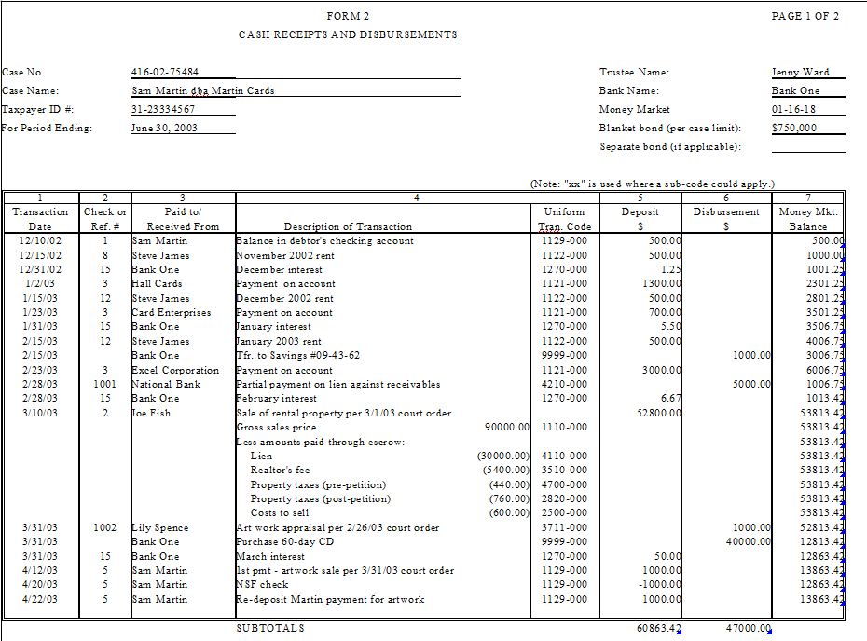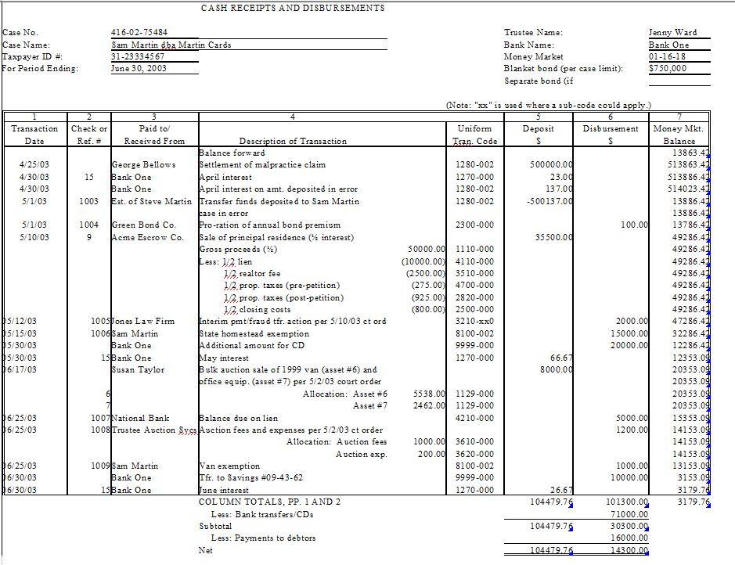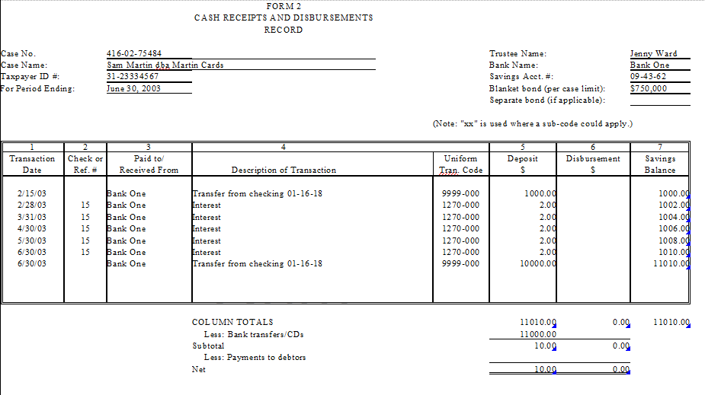
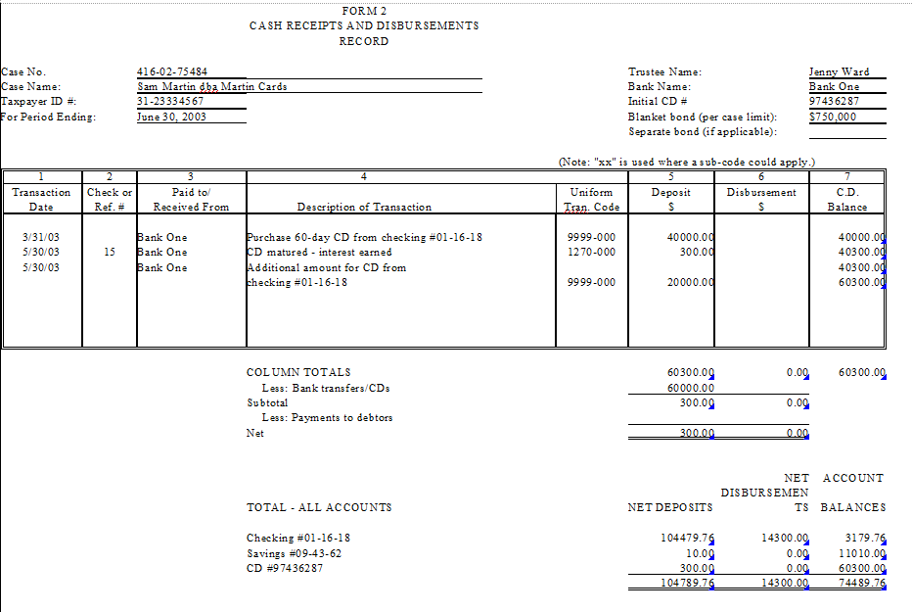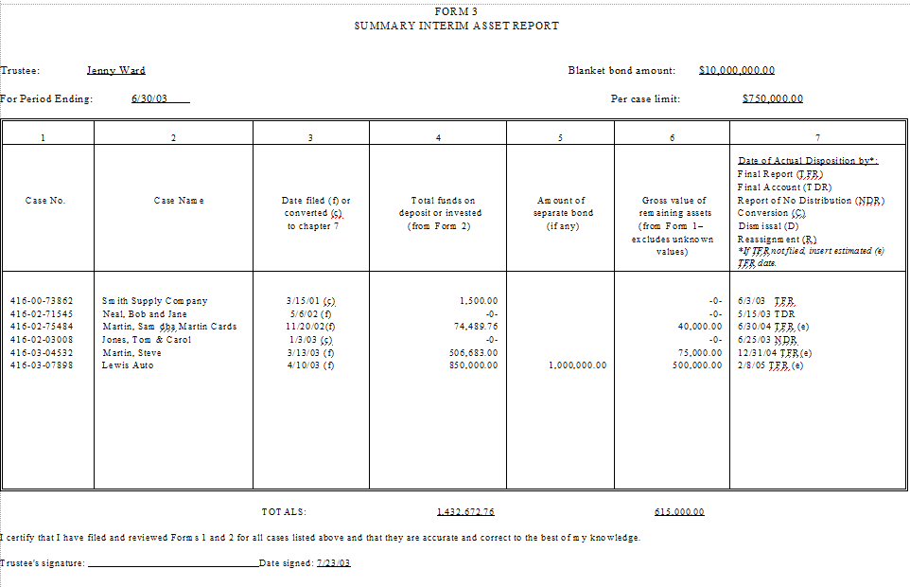

SAMPLE CHAPTER 7 CASE #2
AND ILLUSTRATIVE FORMS 1, 2 AND 3

Sample Case #2 has been added to illustrate how a successor chapter trustee should prepare Forms 1 and 2. As noted in the instructions for Form 1 at page Forms page Forms-4, if a trustee is serving as a successor trustee in a chapter 7 case, Form 1 should account for all property listed on the debtor’s original and amended schedules and statement(s) of financial affairs, as well as any assets identified by the prior and successor trustees that were not listed by the debtor. The partial or full administration of assets by the prior trustee should be explained in Notes to Form 1 or under Major Activities Affecting Case Closing.

Sam Martin, dba Martin Cards (“Debtor”), filed bankruptcy on November 20, 2010, in a non-community property state and Jenny Ward (“Ward”) was appointed the chapter 7 trustee. On June 30, 2011, Ms. Ward resigned from the case and Jordan Fritch was appointed as the successor trustee. Ms. Ward’s Forms 1 and 2 as of June 30, 2011, are provided on Sample Case pages 15 and 17. Mr. Fritch’s Forms 1 and 2 as of December 31, 2011, are shown on Sample Case pages 16 and 18.

